CIVIC ASSIST: AI CIVIC TRANSLATOR
Project Overview
An intelligent application that helps citizens understand complex government documents, schemes, and notices. It uses advanced AI to simplify legal jargon, translate content into local languages (Hindi, Tamil, etc.), and provide audio explanations.
Key Features:
- Document Analysis: Upload images or PDFs of government schemes (e.g., PM-JAY).
- Website Analysis: Paste URLs (e.g., pmkisan.gov.in) to extract announcements and deadlines.
- Smart Simplification: Converts bureaucratic text into simple, 10th-grade level summaries.
- Privacy First: Automatically blocks sensitive ID documents (Aadhar, PAN) from processing.
- Studio-Quality Voice: Uses Murf.ai for high-quality Indian accent voiceovers.
End Users
Primary:
- Rural Citizens: Limited proficiency in official languages.
- Low-Literacy Individuals: Cannot read complex text but understand spoken dialects.
- Elderly Population: Struggle with small print and digital interfaces.
Secondary:
- NGO Field Workers: Need to quickly explain rights/schemes to beneficiaries.
- Migrant Workers: Unfamiliar with the local administrative language.

Technology Stack
Frontend (User Interface)
- Framework: [Next.js 14](https://nextjs.org/) (App Router)
- Language: TypeScript
- Styling: Tailwind CSS
- Icons: Lucide React
- Animation: Framer Motion
- State Management: React Hooks (use-civic-analysis.ts)

Backend (API & Logic)
- Framework: [FastAPI](https://fastapi.tiangolo.com/) (Python)
- Server: Uvicorn (ASCII protocol)
- HTTP Client: Httpx (Async requests)
- Web Scraping: BeautifulSoup4 (for URL analysis)

AI & Third-Party Services
- OCR (Text Extraction):Groq Vision API (Model: llama-3.2-90b-vision-preview)
- Itelligence Engine: Groq API (Model: llama-3.3-70b-versatile)
- Text-to-Speech (TTS)
- Primary: [Murf.ai API](https://murf.ai/) (Ultra-realistic voices)
- Fallback: Browser Web Speech API

Project Architecture
The application follows a decoupled *Client-Server Architecture
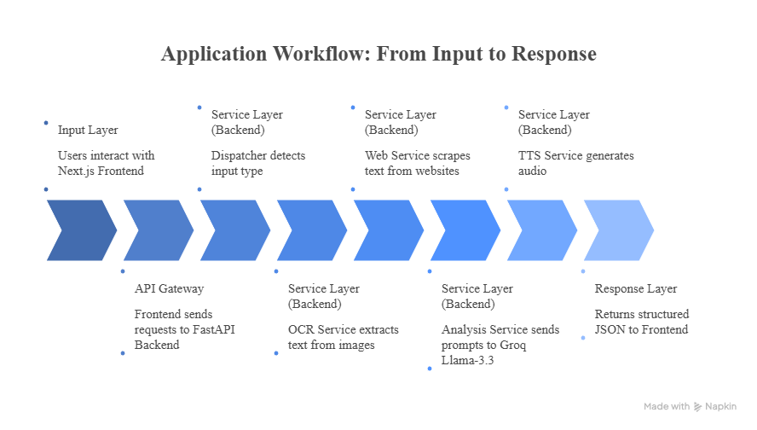Result/Outcomes
The expected results and outcomes of this project are significant:
  - Increased Access to Information: More individuals will be able to understand and access government schemes, legal rights, and public notices.
  - Improved Civic Engagement: Empowered citizens will be more likely to participate in civic processes, such as voting and community meetings.
  - Reduced Inequality: By leveling the playing field, the project will help to reduce inequalities in access to information and resources.
